Mission
- Goat Specialist
- Admin

- 5,082 posts
- Gender:Male
- Location:Monroe, MI
- Interests:Scholarly piracy, designing and creating haunted house rooms and props, movies, abstract thinking, abstruse thinking, obstructive thinking, ideating, random thinking, movies, cartoons, movies, movies scores, cycling, world peace and small furry dogs, movies, writing, drawing, personal skills training, gremlins and, of course, lest I forget, movies.
Posted March 31, 2012 · Report post
This is from William Red Wake's fascinating thread Period Publications for the Private and Public use of Privateers (including ongoing emphasis on alliteration). I was going to comment on it there, but it resurrected a question I had about GAoP fire-fighting on ships and I didn't want to destroy the clean lines of William's topic with a lot of irrelevant discussion about fire-fighting.
Anyhow, here is the document:
On 3/30/2012 at 6:45 PM, William Red Wake said:
DAY 38: This is a 1724 document about firefighting in Boston. It's a list of articles signed by a Fire Society and a precursor to modern fire departments. It's set up on 11" x 17"
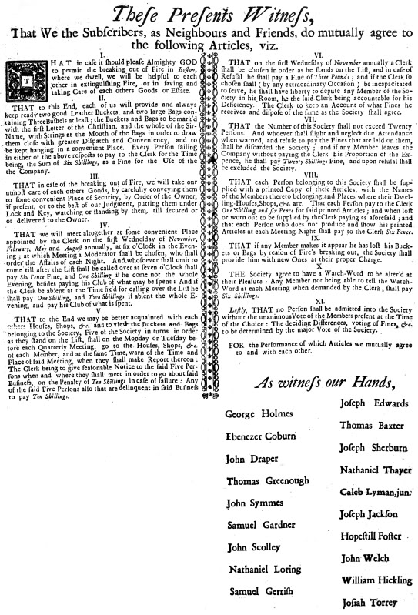
Question 1
The document gives some neat details about fire-fighting on land from this time. I wonder what "the two large bags containing Three Bushels at least" are? What do they contain?
Question 2
This is a long-standing question I've had about shipboard fire-fighting. I read in W.R. Thrower's (too often unreliable) book Life at Sea in the Age of Sail. (Between this and, more particularly, his book The Pirate Picture, I have found enough provably incorrect facts that I don't trust him without corroborating what he says.) From the book:
"For a long time ships all carried piss tubs in various places, which not only served the purpose indicated but also provided ‘fire points’, to use the modern term. With the ever-present risk it was essential to have water supplies handy, and using urine instead of sea water waved work: filling buckets over a ship’s side is never easy and is especially difficult when an ample supply of water is suddenly needed to douse a fire. Urine somehow acquired a reputation for being better than water for extinguishing fires…” (Thrower, Sea, p. 82)
Is this generally true? Is their proof for it? Was it a GAoP practice? Is there proof of that?

William Brand
- Mercury Malefactor
- Admin

- 8,884 posts
- Gender:Male
- Location:Logan, Utah
- Interests:My name is William Pace and I live and work as a graphic designer, illustrator and photographer in Northern Utah. I'm married to the lovely Tracy Pace and we have three children. In addition to all things art, I enjoy traveling and meeting new people from every walk of life. I've always been a fan of history, theology, and of course, Pyracy.
http://www.youtube.com/watch?v=PSkt-q-HihQ
Posted March 31, 2012 · Report post
Short answer. I have no idea.
Long answer. I've heard speculation from pumps to buckets, but never piss tubs. There are many examples of 'fire restrictions' and I've seen several documents that talk about the snapping of anything that will cause a spark and the limitations of smoking and lanterns in various parts of the deck. The tradition of smoking forward is still strictly observed by captains even today. A careless pirate aboard the Liberty Clipper at Pirates in Paradise allowed her cigarette to be carried into the rigging while smoking amidships. The captain placed the lady in the brig 'verbally speaking'.
You become very aware of fire when surrounded by canvas and wood powered by wind.

Dutchman
- Has anyone seen my cousin?
- Admin

- 1,773 posts
- Gender:Male
- Location:tidewater virginia
Posted March 31, 2012 · Report post
mission, thats the thory of piss tubs. i have not run across any documentation on them though- not that i have been looking for it either. it would make some sense to use piss buckets in this fasion on larger ships where the tumbleholm may foul or tip a water bucket coming up the hull. I do have an illustration somewhere that shows the bilge pumps of a ship emptying on deck and having leather hoses (more like tubes) to direct the flow overboard or (i imagine, no proof though) onto a fire if needed. the other issue with the bilge pumps is keeping them primed. if you lose the prime it takes a while to get them flowing, which would be bad for fire fighting.
if grace has not packed the books, i'll take a looksee

Swashbuckler 1700
- Dread Pyrate
- 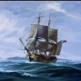
- Member

- 1,115 posts
- Gender:Male
- Location:Europe
- Interests:pyrates, pryvateers, naval military and other history, different books, good movies, music (a little bit), drawing, games,...
Posted April 1, 2012 · Report post
On 3/31/2012 at 8:44 AM, Mission said:
This is from William Red Wake's fascinating thread Period Publications for the Private and Public use of Privateers (including ongoing emphasis on alliteration). I was going to comment on it there, but it resurrected a question I had about GAoP fire-fighting on ships and I didn't want to destroy the clean lines of William's topic with a lot of irrelevant discussion about fire-fighting.
Anyhow, here is the document:
On 3/30/2012 at 6:45 PM, William Red Wake said:
DAY 38: This is a 1724 document about firefighting in Boston. It's a list of articles signed by a Fire Society and a precursor to modern fire departments. It's set up on 11" x 17"
Question 1
The document gives some neat details about fire-fighting on land from this time. I wonder what "the two large bags containing Three Bushels at least" are? What do they contain?
Question 2
This is a long-standing question I've had about shipboard fire-fighting. I read in W.R. Thrower's (too often unreliable) book Life at Sea in the Age of Sail. (Between this and, more particularly, his book The Pirate Picture, I have found enough provably incorrect facts that I don't trust him without corroborating what he says.) From the book:
"For a long time ships all carried piss tubs in various places, which not only served the purpose indicated but also provided ‘fire points’, to use the modern term. With the ever-present risk it was essential to have water supplies handy, and using urine instead of sea water waved work: filling buckets over a ship’s side is never easy and is especially difficult when an ample supply of water is suddenly needed to douse a fire. Urine somehow acquired a reputation for being better than water for extinguishing fires…” (Thrower, Sea, p. 82)
Is this generally true? Is their proof for it? Was it a GAoP practice? Is there proof of that?
At least there is urinals shall found on QAR. And perhaps urine was stored in some way. For example Bart's crew's water run out in some long voyage and pirates needed to drink pee instead of water..... Some of that pirate romance

Mission
- Goat Specialist
- Admin

- 5,082 posts
- Gender:Male
- Location:Monroe, MI
- Interests:Scholarly piracy, designing and creating haunted house rooms and props, movies, abstract thinking, abstruse thinking, obstructive thinking, ideating, random thinking, movies, cartoons, movies, movies scores, cycling, world peace and small furry dogs, movies, writing, drawing, personal skills training, gremlins and, of course, lest I forget, movies.
Posted April 1, 2012 · Report post
On 3/31/2012 at 0:54 PM, Dutchman said:
mission, thats the thory of piss tubs. i have not run across any documentation on them though- not that i have been looking for it either. it would make some sense to use piss buckets in this fasion on larger ships where the tumbleholm may foul or tip a water bucket coming up the hull. I do have an illustration somewhere that shows the bilge pumps of a ship emptying on deck and having leather hoses (more like tubes) to direct the flow overboard or (i imagine, no proof though) onto a fire if needed. the other issue with the bilge pumps is keeping them primed. if you lose the prime it takes a while to get them flowing, which would be bad for fire fighting.
if grace has not packed the books, i'll take a looksee
Most interesting! If you find the book, I'd appreciate anything you find.
This is the sort of thing I dislike about Thrower - he only sporadically gives his sources, so you never know what's true and what's rumor in his book. It's an awful way to write history.

Dutchman
- Has anyone seen my cousin?
- Admin

- 1,773 posts
- Gender:Male
- Location:tidewater virginia
Posted April 1, 2012 · Report post
books are packed i'm afraid. will take a while to get back to them, but this has my interest so it'll be on a to do list once i can get back into the research mode

